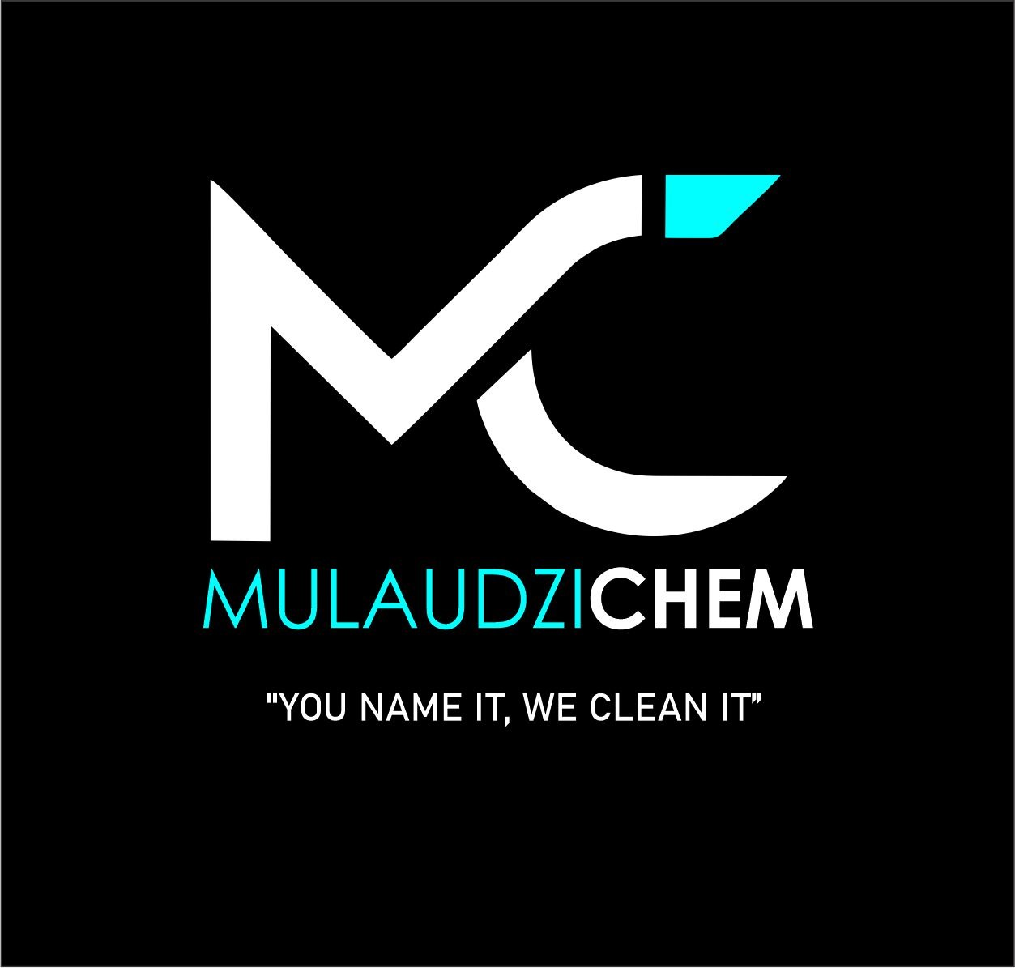
Mulaudzi Solutions Pty Ltd

Amberfield City , 0175, TEL: 0792130538 or 0732605131
Email: shanemulaudzi@gmail.com & chulufuzile@gmail.com
Banking Detail Acc #1290716941
Acc holder : Mulaudzi Solution
Bank Name : Capitec

PRICE LIST

SIZE | CHEMICALS | 5litre | 25litre
 | HOUSE HOLD PRODUCT
 | Bleach 6% | R100 | R300
 | Super Dish wash | R100 | R300
 | Stay Soft (peach & lavender) | R100 | R300
 | Washing powdered Auto | R120 5kg) | R450(25kg)
 | Washing powdered hand | R120 | R450
 | Laundry Spotter | R100 | R300
 | Laundry liquid | R100 | R300
 | Floor and & Tile cleaner | R100 | R300
 | Kitchen fat degreaser | R120 | R300
 | Handy Andy cleaner | R100 | R300
 | Oven cleaner | R120 | R300
 | Pine Gel | R150 | R700
 | Citrus Gel | R200 | R900
 | Toilet Paper ( 48 pack)
 | 1PLV 500 sheet | R250
 | 2PLV 250 sheet | R250
 | Thick Bleach | R100 | R300
 | Black fluid | R150 | R600
 | Pine Disinfectant | R150 | R700
 | Disinfectant Detergent | R100 | R350
 | Toilet bowl Cleaner | R100 | R300
 | Furniture Polish | R180 | R750
 | Furniture Spray 400ml | R60
 | Wax Floor Polish
 | 1kg | R100
 | 2kg | R150
 | 5kg | R260
 | 25kg | R1100
 | Feather duster
 | Short | R80
 | Long | R120
 | Micro fibre cloth | R40
 | HOUSEHOLD PRODUCT | 5LITRE | 25LITRE
 | Dish Towel | R25
 | Mop trolley
 | Single Bucket Plastic | R750
 | Double Bucket Plastic | R1200
 | Double Bucket Steel | R2600
 | Hi shine floor polish | R250 | R950
 | Bubble bath | R90 | R 300
 | Mop 400g | R80
 | Mop Industrial | R150
All 25l container are on exchange basis. if not, R50 replacement fee will be charged

Sales contact:

Shane :0792130538

Chulu :0732605131

